Running Head: Overview of Neural Network Simulator

Overview of Design and Functionality of
Neural Network Simulator Program

Jason Sachan
Ottawa University
This program was an effort to recreate a Neural Network Simulation program I had written in college back in the early 90’s. I was a Computer Science major when I first created the program, but switched to Psychology later on. My interest in Neuropsychology stimulated me to keep working on the program, despite the change in major. I originally wrote it in Turbo Pascal, as a console application (i.e. designed to run in a text based DOS operating system, not a graphical OS like Windows). fortuntly, I eventually quit work on the major and the program.
Seven years later, I had an opportunity to go back to school and finish my Bachelors degree. I decided IT would be a better career path at this stage in my life, so I started studying programming again. I decided that modernizing my old program with Object Oriented Design and a Graphical User Interface would be an excellent way to demonstrate my newly learned skills. This program was written in C# using the .NET framework.
The following documentation is an introduction to the program.

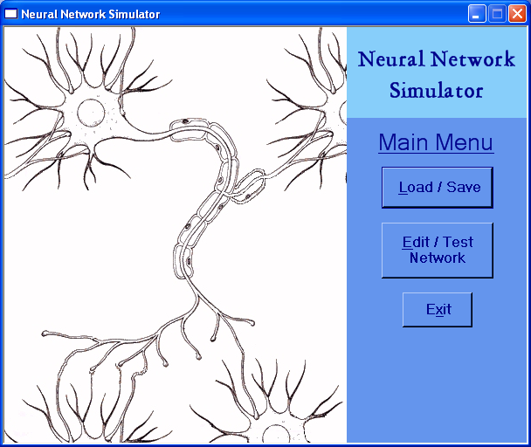
Neuron
Attachments

Overview:
To understand this program, you must first understand a little about neurons. The first screen loaded shows a drawing of a neuron. Every neuron has attachments to other neurons (the root like extensions). At any given moment, a neuron receives a certain amount of stimulation from the other neurons that are attached to it. If that stimulation is over a certain threshold, it will trigger that neuron to fire. When it fires, it sends stimulation on to the neurons that it is attached to. This process can cascade through a network of neurons moving a signal from one point, through any number of neurons to another point. Most neurons in a brain are of this type, only interacting with other neurons. Outside of the brain, there are other types of nerve cells that can interact with other things. The nerve cells in the eye can detect light, for example, or nerves throughout the body can cause muscles to contract. In this light, you can see how your own hand flinches away from a hot object it has just touched. Some nerve cell detects the heat, a signal is passed through a series of neurons which determine the signal is too strong, and a signal is sent back to a muscle in the arm which jerks the hand away. It is this type of reflexive neural processing this program is simulating.
There are three types of Neurons you can create. One basic type that only interacts with other Neurons, and two derived Neurons called Sensory and Motor. These can be used to detect things in the environment and act against it, respectively (as in feeling heat, and moving a muscle). Within the program, each Neuron you create is an instantiation of an Object. You can set certain variables for each Neuron to customize how they interact with other Neurons. See the screen shot on the next page:
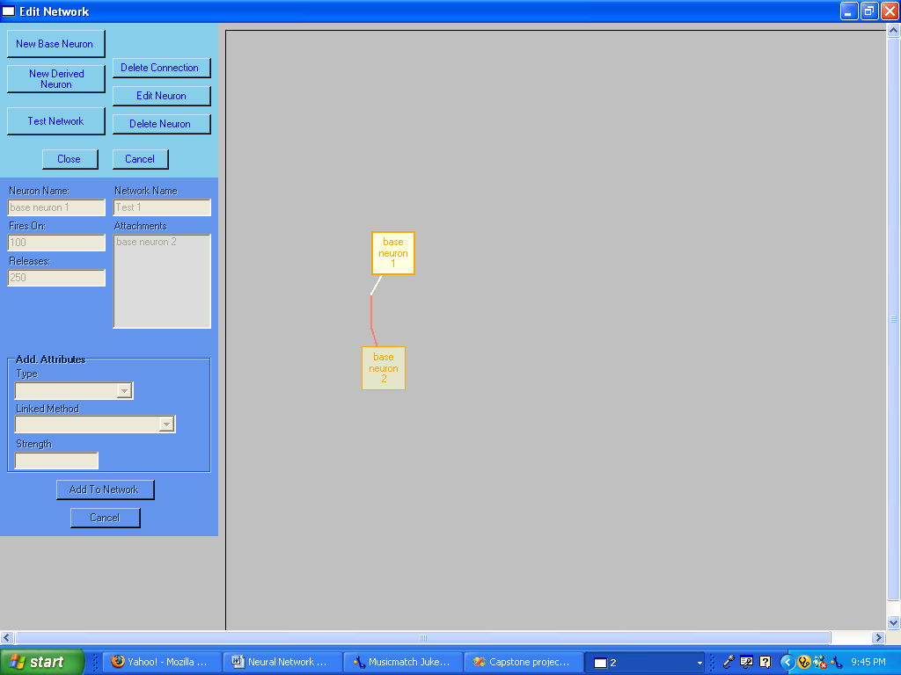
You can create a Neuron by clicking on “New Base Neuron” or “New Derived Neuron”. Two Base Neurons have been created here. When you click the button to create a Neuron, you can choose the Name of the Neuron and set the Fires On and Releases values. Fires On represents the threshold that the Neurons charge must surpass to cause it to fire. Releases is the amount of stimulation the Neuron sends to all other Neurons it is attached to when it does fire. Each Neuron keeps track of an internal Charge value. It is the Charge value that must exceed the Fires On value to cause the Neuron to fire. Additionally, when a Neuron does fire, it is the Charge value of all the other Neurons it is attached to that is increased by the Releases value of the Neuron that just fired.
In the example above, base neuron 1 has a Fires On of 100, and a Releases of 250. If base neuron 1’s internal Charge value were to become greater than 100, then it would fire and release 250 units onto all the Neurons it is attached to (in this case, base neuron 2). That would increase the Charge of base neuron 2 by 250. In it’s turn, if the Fires On value of base neuron 2 was 250 or less, then it would fire due to the stimulation of base neuron 1. If it was greater than 250, then it would require stimulation from more sources than just base neuron 1 to make it fire. It should be noted that each time a Neuron checks to see if it will fire its charge is reset to 0, whether or not it actually fires.
Derived Neurons are created to give the Network an interface with the testing environment. For this program, a simple test environment was created where a “creature” (large white dot) could navigate through a “world’ filled with green and blue dots. The green dots represent food and the blue ones are obstacles that can get in its way.
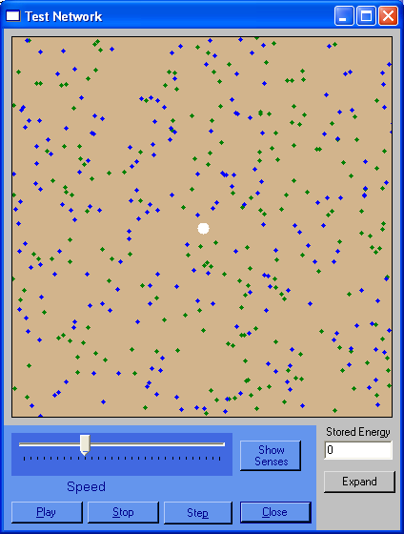

Every time you create a Derived Neuron, you link it to a Method that allows it to interact with the test environment. For this test environment, you can choose a sensory method that detects food left, right, above, or below the creature, if the creature has not moved from the last cycle of Neuron processing, if the creature has just eaten food (moved over a green spot), or is hungry (“Stored Energy is below 0”). Every “cycle” reduces the Stored Energy by 1 and eating a green dot increases it by 100. For motor methods, you can choose from move left, right, up, or down. Each Derived Neuron can have a Strength assigned to it to give different characteristics to the same method. You can, for instance, have a Neuron linked to MoveUp with a Strength of 1 and another Neuron linked with a Strength of 5 so your creature can have both a ‘walk’ and ‘run’ movement speed for different scenarios.
Here is a simple scenario:

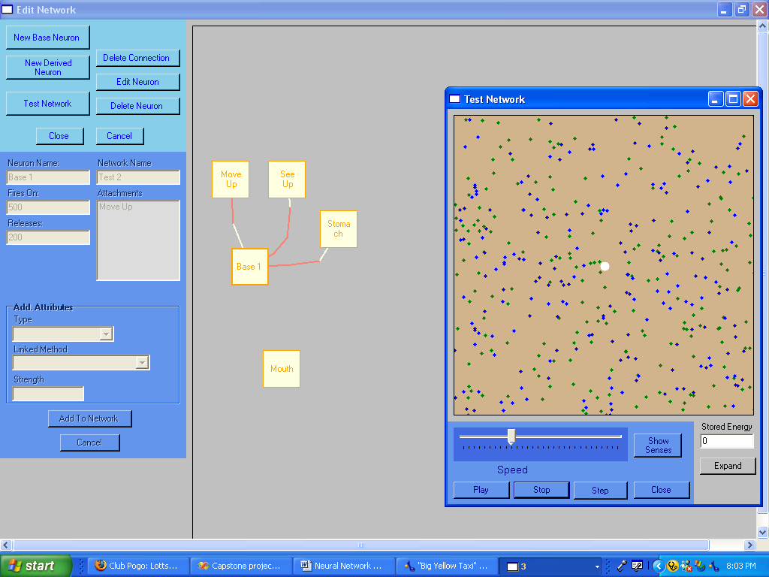

This Network has 5 Neurons. As you can see, Base 1 is a Base Neuron and has a Fires On of 500 and a Releases of 200. That means it must receive 500 units of stimulation in one cycle to cause it to fire. If it does, it will release 200 units onto its attachments (the Move Up Neuron.) Both the See Up and Stomach Neurons are attached to Base 1. The red attachment lines are yellow where they touch the Neuron that the attachment runs from. If you click on them, you can see that See Up has a Fires On of 1 and a Releases of 200, and it is linked to the IsFoodUp method and has a Strength of 25. Since Sensory Neurons take their stimulation from an outside method, the Fires On is irrelevant. For this Neuron, it fires if the IsFoodUp method detects a green spot within 25 dot-widths of the center of the creature. If it does, it releases 200 units onto the Base 1 Neuron. The Stomach Neuron is linked to the IsHungry method and fires whenever the Stored Energy value goes below 0. If it does, it releases 300 units onto the Base 1 Neuron. As we can see above, Base 1 won’t fire unless it receives 500 units of stimulation in one cycle (since it clears its charge back to 0 each cycle.) When this happens, Base 1 releases 200 units onto the Move Up Neuron, which has a fires on of 200 and a releases of 1. This would cause Move Up to fire, which it does by calling the MoveCreatureUp method. This moves the creature up 1 space since Move Up has a strength of 1.
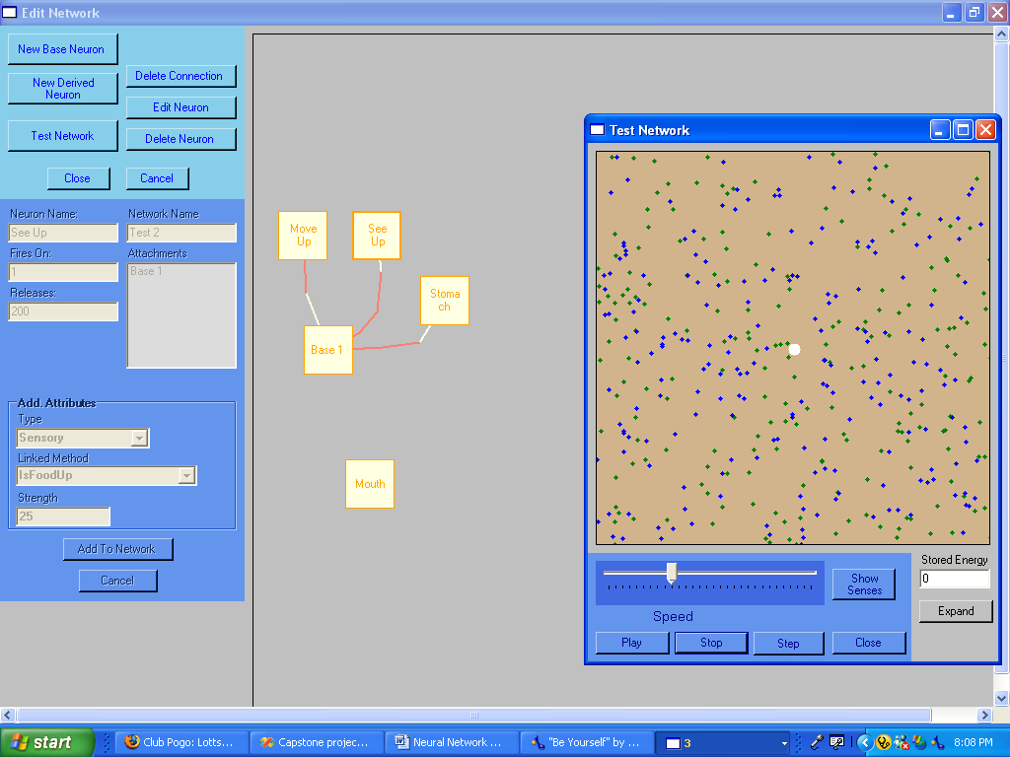

As you can see, this creates a kind of “Logical circuit” where the creature will move up only if both a green dot is found above the creature and it has a stored energy value below 0. As you might expect, this creature is not likely to survive long, but if many of these logical circuits are built into a network, very complex behavior can be programmed. This program allows the user to create very simple, yet very natural, forms of artifical intelligence.
The editor is fairly versitile. You can create new Neurons at any time with the “New Base Neuron” and “New Derived Neuron” buttons. Any existing Neuron can be edited by clicking on the Neuron and then clicking “Edit Neuron”. Clicking “Delete Neuron” will remove the Neuron from the Network and all connections from AND to it. You can create a connection from one Neuron to another by simply clicking first on the Neuron the connection is coming from, then at least once(but as many times as you want) on any part of the gray surface, then one final time on the other Neuron. This plots a multi-segmented line between the two Neurons. You can right click on any Neuron and drag it to a new position. Any connections from or to it will also move when the Neuron is moved.
With the test environment screen, you can Step through one cycle at a time, or let it run freely. You can adjust the speed as it runs. You can build a network, test it, and add or remove Neurons as needed before testing it more. Clicking the Show Senses button outlines the areas the IsFoodLeft, etc… methods check for food. From the main screen, you can go to the Load/Save screen and load or save Networks to disk.
Finally, you can see a large Network I created. This creature is quite successful at surviving in the test environment. Whenever it finds itself in an area where it can’t detect food or can’t move, it is able to pick a pseudo-random direction and travel that way until it finds better hunting grounds.
